Pokhara University

Level: Bachelor | Semester – Spring | Year : 2008
Programme: BE |  | Full Marks: 100
Course: Integrated Digital Electronics |  | Time : 3hrs.

Candidates are required to give their answers in their own words as far as practicable.
The figures in the margin indicate full marks.

Attempt all the questions.

 | - A BJT inverter is to be designed to have a equal low level & high level noise margin. Compute the no. of loads the gate can drive without degrading the system.  Vcc = 5V , β = 50 , V_{BE} = 0.7 , V_{CE} = 0.2V.  - Draw a 3 input positive logic NOR gate and explain its operation. | 8  7
 | - Analyse the DTL circuit shown.  Find h FE (min) if two similar gates are to be driven by this circuit.Also find noise margins.  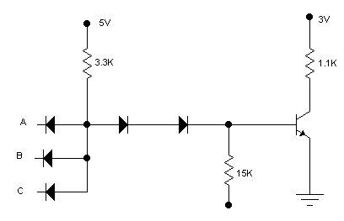  - Discuss IIL logic and its advantages over saturated logic. | 8  7
 | - Briefly explain the concept of three state logic TTL circuit and explain its operation.  - Explain the high speed TTL logic and its application in IC technology. | 7  8
 | - Given 4 enhancement mode NMOS transistor and 1 depletion mode CMOS transistor. Demonstrate the realization of as many functions as possible.  - Draw a two input NAND NOR realization in ECL gate. How ECL differ with TTL logic? | 8  7
 | - How the charge transfer mechanism is carried out in CCD? Explain the application of CCD.  - Explain the application of switch in multiplexer mode. | 8  7
 | - Write the VHDL code for full adder.  - Why is the CMOS switching speed is greater than PMOS/NMOS.  - Draw the circuit diagram of dynamic MOS cell. | 5  5  5
 | Write short notes on (Any Two)  - VHDL a good design sense.  - Logic level diagram  - Diode transmission gates | 2×5

